Lab 5: Tableau Advanced III

Name:

1. Cross Table: Working with Totals and Aggregation:

(1). Add Grand Totals to the rows and columns, add all subtotals (Country, Product Line, Color and Sum of Sales);

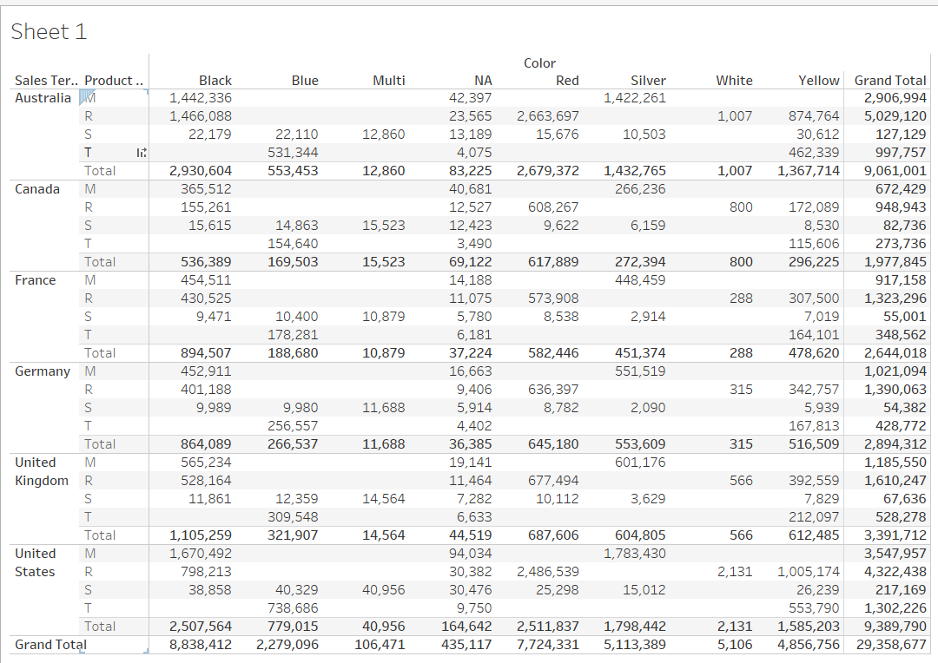

1. . Change the sum aggregation to the averages, and change the labels;

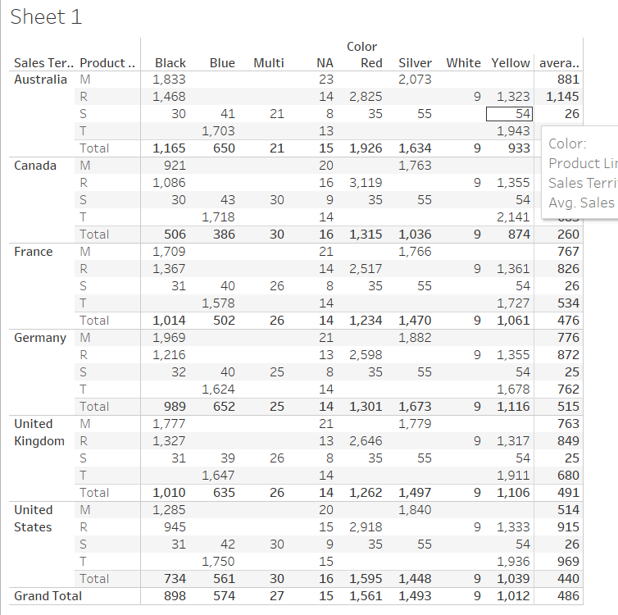

(3). Use “Total All Using” to average the values in the View;

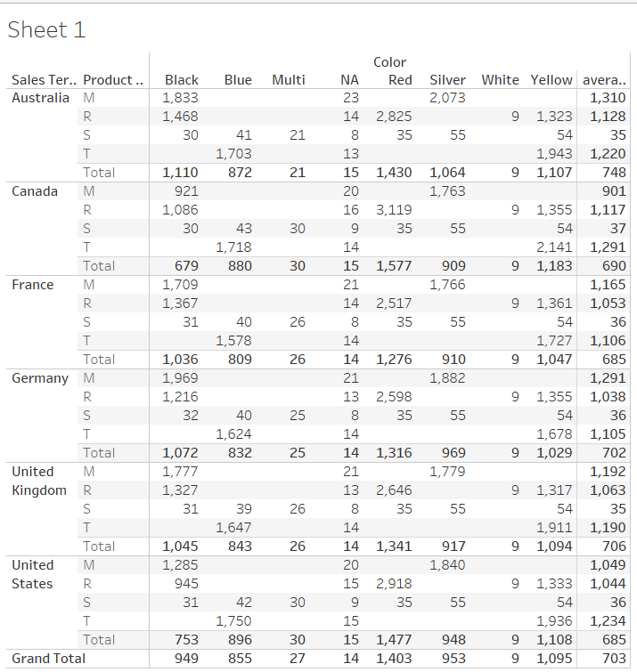

2. Cross Table: Creating Highlight Tables and Heat Maps:

(1). Create highlight table highlighting the Sum of Order quantity ordered from different model names from different customers: Set color center to 10.

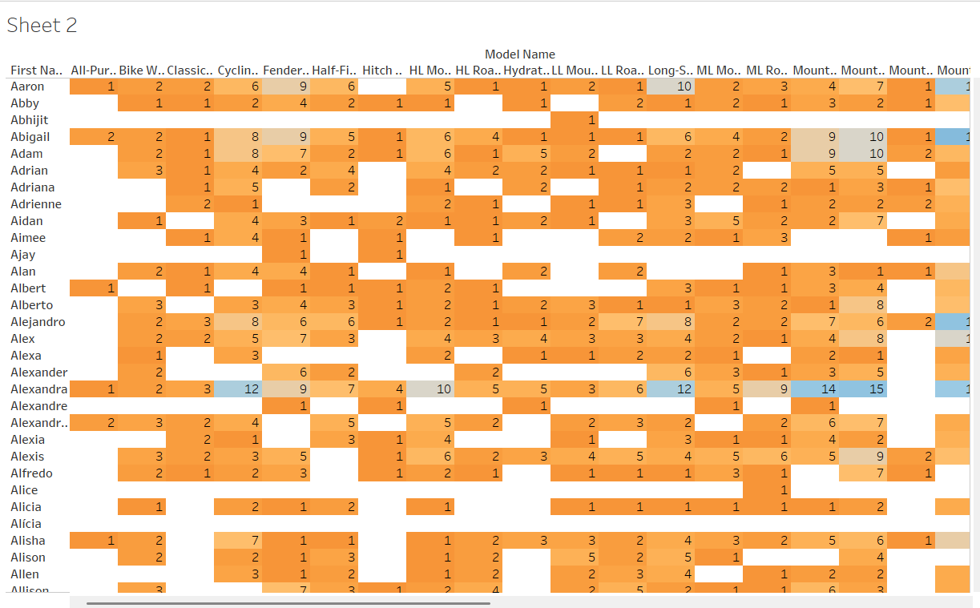

1. . Create a heat map in the crosstab to compare the product cost and unit price in different regions from different product line.

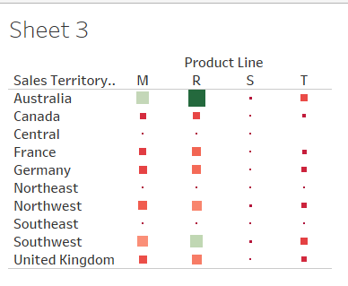

3. Create the calculated fields:

(1). Create the calculated fields: Unit profit = unit price – product standard cost; Total profit = unit profit \* order quantity; Profit Margin = total profit/sales amounts; Overall average profit margin = average (total profit)/ average (sales amounts);

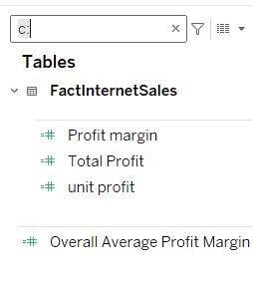

1. . Compare the average of profit margin and overall average margin profit by the product line;

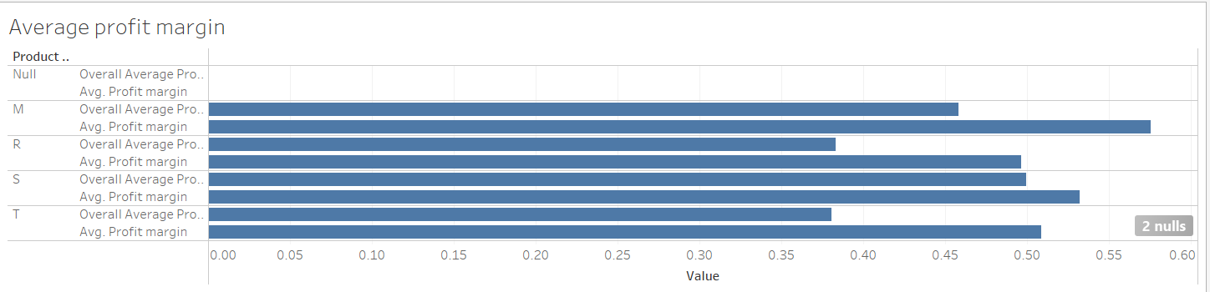

4. Create Calculations using strings, mix types, and date functions:

(1). Create a “Customer Full Name” field that concatenate “First Name”, “Middle Name” and “Last Name”;

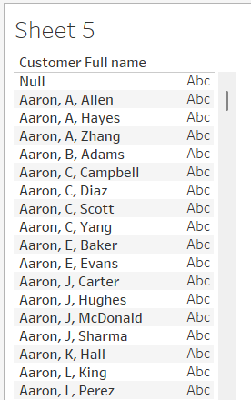

(2). Create a concatenate field including “Customer Full Name” and yearly income;

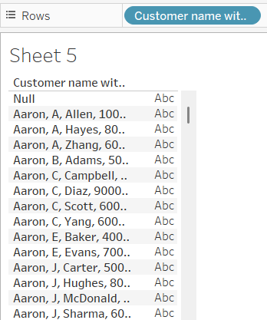

1. . Use the date difference function to calculate the date/month differences;

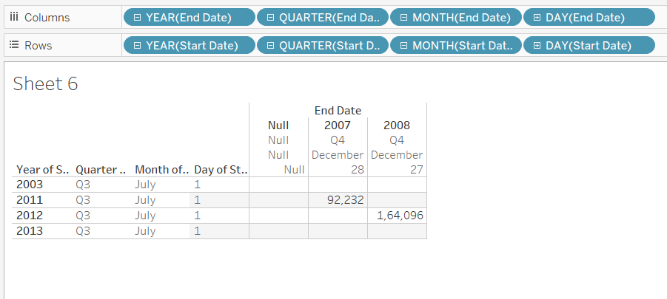

5. Running total and percentage of the total:

(1). Create the running total and percentage of the total using pane across (Due Date, Product Line, Color and Sales Amount;

Pane Across (Calculating from left to right, pane is one category, not a table, not a subcategory;)(year is one pane)

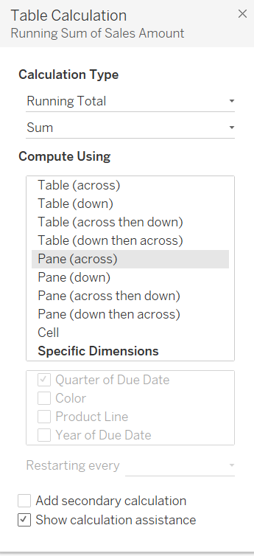

Q2 = Q1+prior Q2

Pane Down (Calculating is from top to down)(each pane is one category;)

Table Across (from left to right each unit of analysis is the table, all columns)

Table Down

Cell(each cell is a unit of analysis)

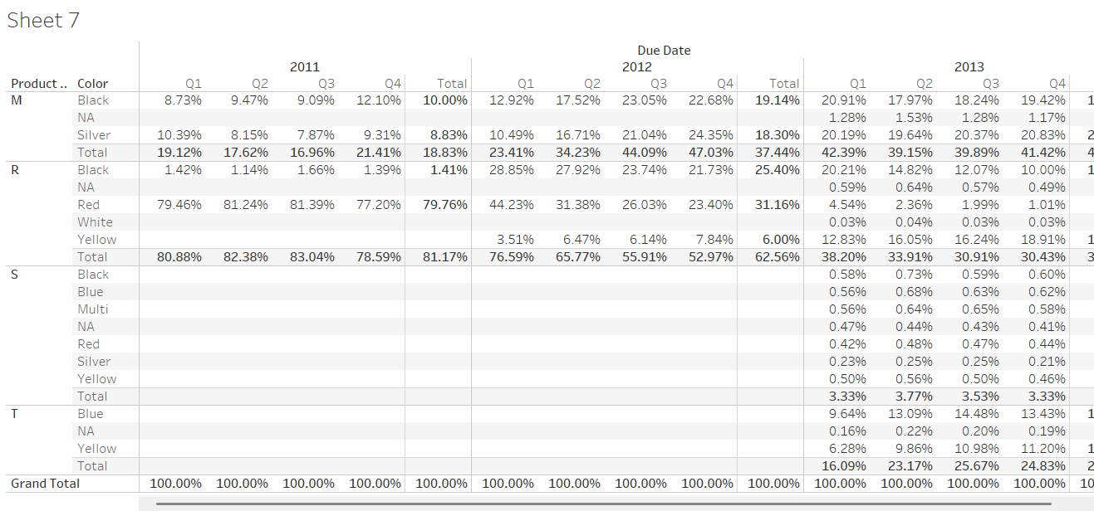

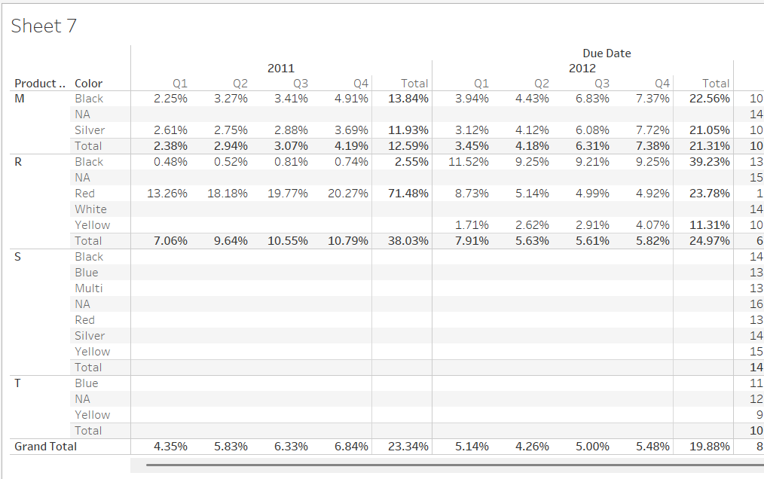

(2). Create ranks using quick table calculation (Country, Region, and Profit);

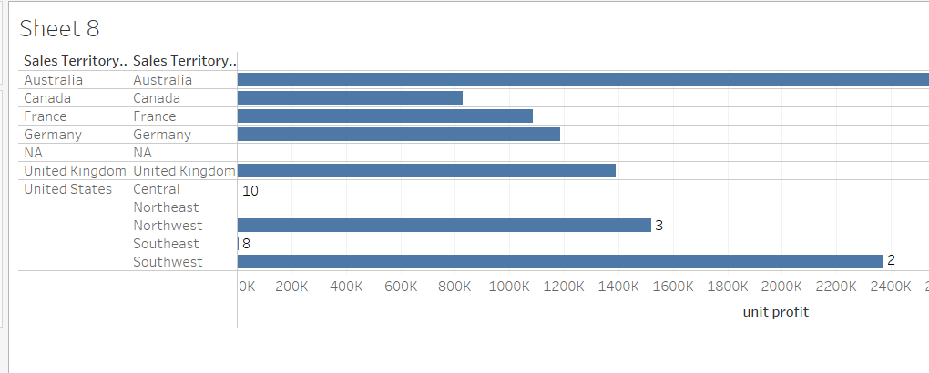

Question 1:

This table shows a quick table calculation using percent of total. How was it computed?

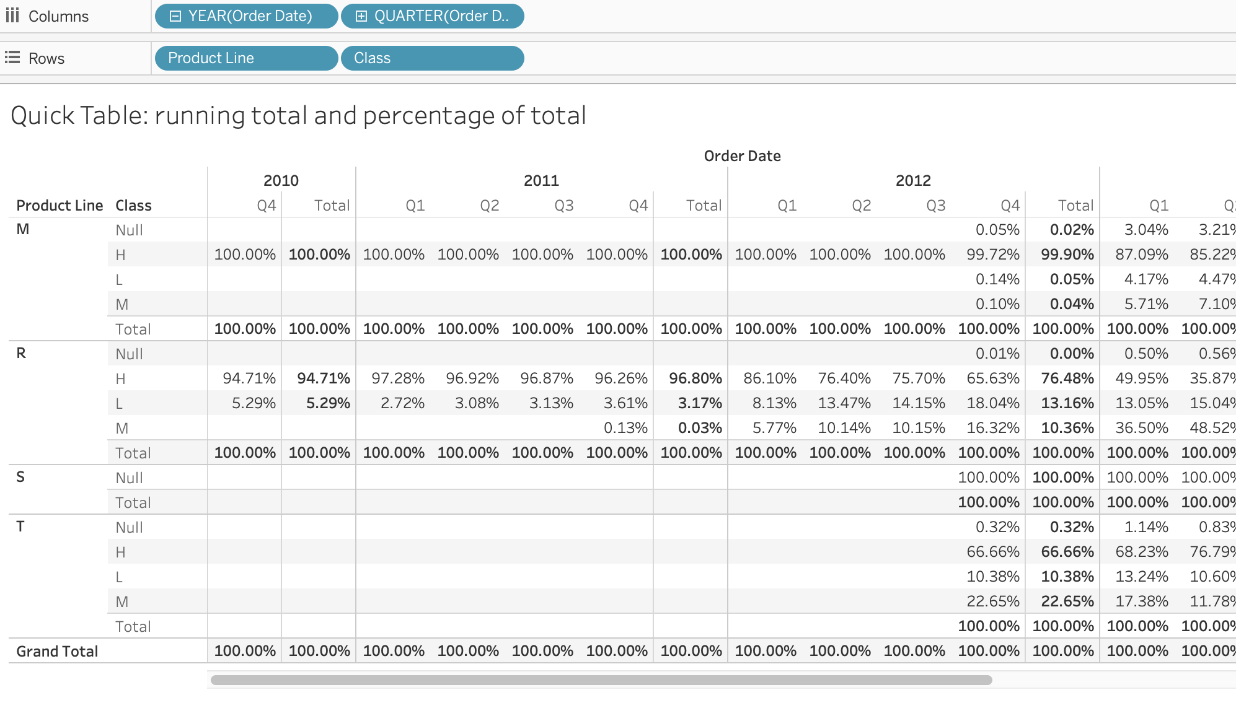

a. Table (across)

b. Table (down)

c. Pane (across)

d. Pane (down)

Question 2:

The table calculation has a compute using value of Table. If we change the value to Cell, what do you expect the outcome to be?

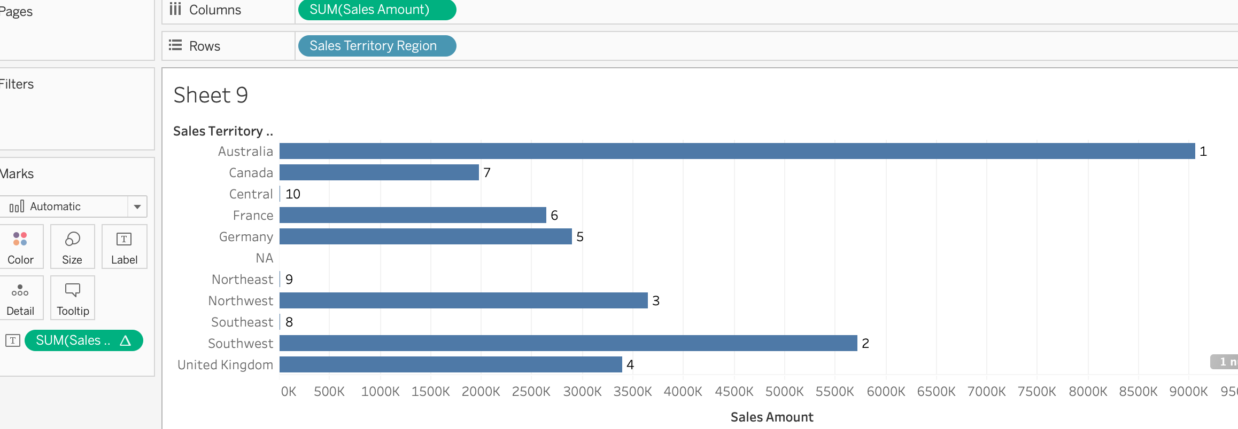

a. All regions are ranked as 1;

b. Each region is ranked against all other cells;

c. Countries are ranked against the countries in their region;

d. Regions are ranked by their best year.

6. Advanced Calculation: Aggregate Dimension:

(1). Aggregate dimensions using max, min, count, count distinct, attribute;

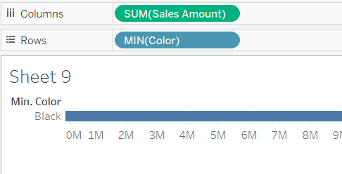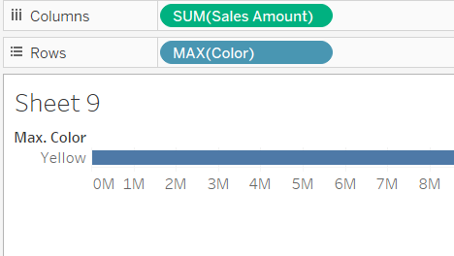

1. . Create a new field: Profitable (avg of unit profict) by Product Line, categorizing product lines into two levels: Profitable and Non-profitable:

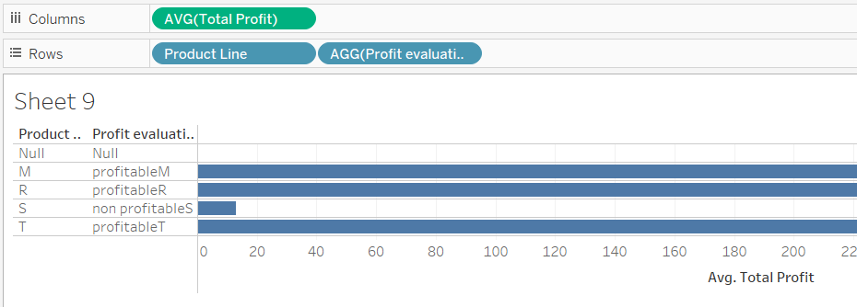

Question 3:

You would like to know the number of unique codes are in your sales region. Which aggregation would you select?

a. Count distinct;

b. Attribute;

c. Minimum;

d. Maximum;

7. Union data and merge fields:

Use nuts data;

1. . Union all the tables (almonds, hazelnuts, macadamias, pistachios, walnuts) into one data source;

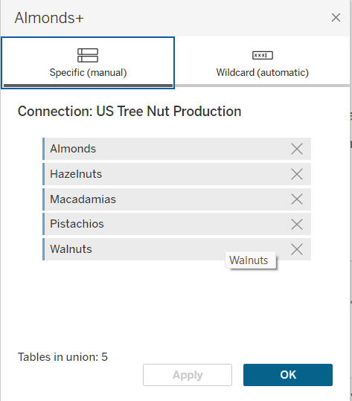

1. . Merge fields that are not correctly identified, and rename the columns that are misidentified;

